Evaluation and optimization of pedestrian detection approaches for driving assistance applications

Sarang Gokhale
RAV 503 Capstone Project
Final Report

Abstract

The focus of the project is to evaluate some of the state of the art object detection algorithms for the task of pedestrian detection, intended for a driver alert system for a monocular camera mobile platform like an ARM tablet. Additionally, avenues for architecture based speed-ups and application specific optimizations are explored and implemented. Moreover, specific areas of research are discussed which will potentially improve these algorithms and make them more suitable for this task.

Introduction
Vision based driver assistance systems are currently sold with dedicated hardware and thus have limited availability. These systems need high computing power to perform image processing at real time. Due to the ever increasing computing power of everyday mobile devices, it may be feasible to have a mobile application capable of performing these computations. Moreover, with no requirement of dedicated hardware, such an application will be readily available to end users. To achieve this goal, multiple state-of-the-art algorithms, each addressing a specific problem needs to be combined into an end product. This project addresses a part of this problem by evaluating state-of-the-art algorithms in object detection on their performance for pedestrian detection using CPU-only instructions. A study into possible speed-ups from using ARM's NEON instruction is provided. A major contribution of this project is a combination of such algorithms which performs better than the individual algorithms, and is capable of operating on the limited hardware resources available on mobile devices. Additionally, several possible optimization techniques are explored for their trade-offs between speed and accuracy.

Prior Work
Several object detection approaches exists which focus on detecting deformable objects like pedestrians. The most prominent ones (high accuracy and speed) use histograms of oriented gradients (HOG) [1] as features to detect the object. HOG based detectors learn the characteristic shape of the object they are trained to detect. Since HOG are not scale invariant, the images need to be up-sampled / down-sampled multiple times, and HOG features calculated at each scales in order to find small and large objects. [2] noted that their algorithm which gives state-of-the-art results spends most of its time rescaling images and extracting features. This leaves avenues for optimizations in these approaches.
Object detection algorithms also suffer from the sliding window approach. Most detectors process image patches with the object to be detected centered and covering the entire image patch. This means a large number of image patches need to be generated from each level of the image pyramid. This is usually done by sliding a window of the required size and aspect ratio along the entire image with a stride of a few pixels. This is far too wasteful, since a large majority on computation is performed on image patches which don't contain the object.
Object candidate generation is a popular preprocessing step that makes even the very computationally costly detection techniques feasible for real-time detection. It does so by generating image patches that are likely to contain an object. This reduces the number of image patches that need to be analyzed by the object detector [3]. Most object candidate generation techniques are similar to [12] and use dense segmentation with unsupervised learning of object patch generation criteria. These approaches, can themselves be modified for trade-off between number of candidates generated (high recall) and accuracy (high precision).
[4] analyses other optimizations for a pedestrian detection system based on projective geometry which can boost the performance of existing algorithms by limiting the search area in the image. This is an application specific technique which assumes that pedestrians are located on the ground plane. Then, using ground plane estimation, which is relatively fast (150fps), and known aspect ratios, a large fraction of the image patches can be filtered out.
[5] provides a comprehensive study of the existing state-of-the-art approaches in pedestrian detection, and [4] focuses on pedestrian detection approaches for a real-time applications. Based on the analysis provided by these studies, ChnFtrs [2] algorithm with its modification detailed in [6] (FPDW), is used as the primary pedestrian detector.
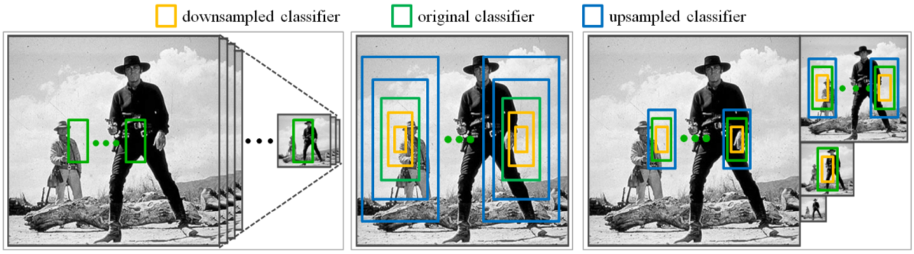(a) dense image pyramid (b) classifier pyramid (c) FPDW's hybrid approach
Fig. 1: FPDW detector. Refer text for details
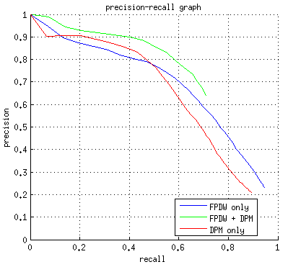Fig. 2a: Comparison of FPDW only, DPM only and the proposed combination approach
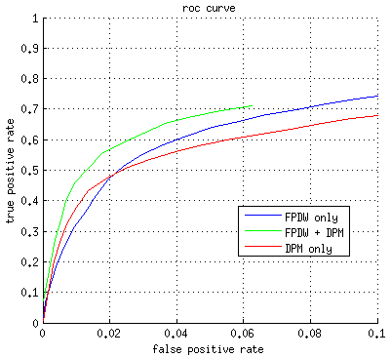Fig. 2b: Comparison of FPDW only, DPM only and the proposed combination approach
When evaluated on the Caltech Pedestrian dataset, which is a set of annotated videos taken from a dashboard camera, FPDW gives a large number of false positives for lower error (false negative) rates (Fig 2a and Fig. 2b). This degree of accuracy is impractical for use in a safety system. However, the advantage of this approach is that the detection is very fast (25 fps), with single threaded CPU execution.
An improvement of FPDW is implemented by [7] (VeryFast) where instead of having one model and multi-scaled images, they have multi-scaled model with one image. This, along with an optimization for soft-cascade design for the Adaboost classifier, gives better accuracy at up to 50 fps. But the authors implementation for this approach is GPU based and is thus not suitable to be directly used for a mobile architecture like ARM.
Deformable Parts Model (DPM) based algorithm from [8] is known to detect objects robustly, but suffers from low frame rate due to the sliding window based approach applied to a densely scaled image pyramid. Also, the accuracy of this approach reduces for very small sized pedestrian windows [11]. DPM also uses HOG features and models objects as a combination of multiple parts. This makes it effective towards detecting partially occluded objects. The only major limitation of DPM detector is that it is computationally intensive with single threaded CPU detection taking over 4 secs for a 640x480 image. Fig. 2a and 2b show that using DPM alone is not sufficient either.
The approach of this project is to use a combination of FPDW and DPM based detectors. First, FPDW is used to generate predictions which are treated as object candidates. After filtering out object candidates occurring at unlikely position in the image, the remaining candidates are passed to the DPM algorithm. The output of the DPM algorithm is then the final output. Fig. 2a and 2b show the comparison of this approach with DPM only and FPDW only detectors.

Approach
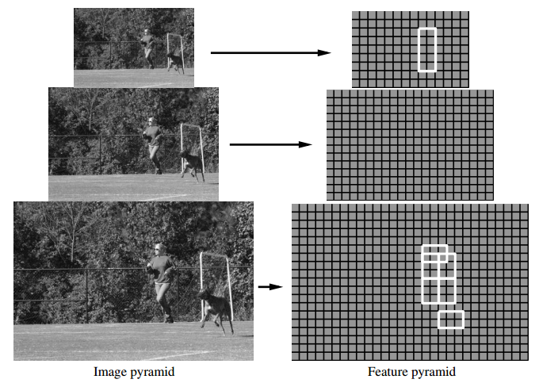Fig. 3: Image and feature pyramid showing 'root' filter and 'part' filters.
  - FPDW
ChnFtrs is based on the Viola and Jones [2001] object detection framework. It uses 'integral channel features' approach where multiple registered image channels are computed from the input image, and then features such as local sums, Haar features and histograms are efficiently computed using integral images. These are then trained using 'soft' cascade' boosting (AdaBoost). This approach also requires densely scaled image pyramid (8-16 scales per octave) since it uses scale variant gradient histogram features.
An improvement to ChnFtrs is introduced by FPDW. Here, approximations to scale variant features are used to reduce computations. Given features for an image, features for the rescaled image (up to an octave) can be approximated. This reduces the number of scales that the image pyramid requires, resulting in speedups of 1-2 orders of magnitude with little loss of accuracy [6]. Fig. 1 from [6] shows the contrast between previous approaches and FPDW. Fig. 1(a) shows the conventional approach using scale variant features, Fig. 1(b) shows the Viola and Jones approach of using scale invariant features, while Fig. 1(c) shows the hybrid approach of FPDW.
The original authors' implementation for FPDW was used without any major modifications. The original implementation used training videos from Caltech dataset with images for training extracted at every 30th frame. This was changed to extract image at every 5th frame. Number of negatives were then increased to match the new number of positives to avoid over-fitting. Another modification was made to the boosting tree configuration. The number of levels was changed from 2 to 3 and the number of weak trees to learn was increased from 2048 to 8196. This gave a noticeably better performance. The threshold for detection was decreased to allow for higher recall at the cost of lower accuracy. The detection results from FPDW were used as object candidates were filtered and passed to the DPM based detector.

  - Object Candidate filtering
The object candidates were filtered based on likelihood of object location within the image. With the average person height of 1.8m [5] and average car dashboard height (and thus camera height) of 0.8m, the image of a standing pedestrian will always intersect the image horizon. In projective geometry, image horizon is set of points where straight lines in the image appear to intersect. The object candidates were filtered based on the distance of their center from the image horizon. To further reduce DPM calculations, objects candidates with FPDW score above a threshold were always considered true detections.

  - DPM
Deformable Parts Model using HOG features is a proven technique for object detection. It exploits dynamic configurations of its parts which allows for a wider variation in object appearances to be accepted. Detection takes place at two image scales. The 'root' filter is found on a lower resolution image while the multiple 'part' filters are found on an image twice the resolution (Fig. 3). The importance of this aspect is well illustrated in a [5]. Secondly, this method has a well-designed learning technique called “latent SVM” which not only can handle a large training set effectively, but also can learn a part-based model without requiring information about exact part labels.
The original authors' DPM implementation, voc-release5, was used with minor changes for optimizations. Profiling on the DPM algorithm shows the computational bottleneck is the floating point convolution between the learned features and the input image features. This step is required to generate a score that determines how close the input image patch is to the learned model.
DPM first generates dense scale pyramid (46 levels) of the input image, and calculates features on each of the scales to form a feature pyramid. A sliding window in used on each of the levels of the feature pyramid to generate feature patches. The sliding window slides by one pixel in the feature dimension resulting in as many as 137x171 feature patches for a 640x480 image. Each of these patches are then convolved with all the root and part filters from the model (in this case, 54). This step alone takes as much as 3 secs using a single threaded non-SSE C-based convolution implementation This excessive computation is required without object candidate selection.
With object candidate selection, we know the scale at which the pedestrian is expected. Thus only two scales are required for the image, one for the root filter and one for the part filters. Also, the sliding window need not generate patches for the entire feature level, but only a small area around the object candidate. This approach can potentially reduce the computations for the convolution step resulting in speed gains by as much as 23(reduction in scales) x 5x5(average reduction in feature patches). This modification was implemented as follows. The image patch represented by the object candidate was rescaled to match the positive sample size used while training the DPM. This patch was then rescaled once more to double its resolution. These two scales were used for detecting with the root filter and the part filter respectively.
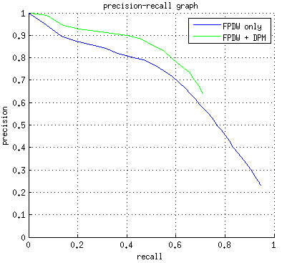Fig. 4: PR plot of FPDW only detections and the proposed FPDW + DPM cascade detections.
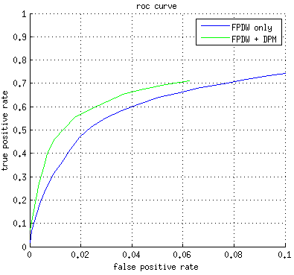Fig. 5: ROC plot of FPDW only detections and the proposed FPDW + DPM cascade detections.
The DPM implementation uses multiple components of an object class. These components are intended to capture multiple poses or orientations of the object. For example, front and side view of a bicycle will be considerably different and the model will learn two components corresponding to the two views. The DPM implementation uses 2 components for detecting people, one for front/back view and another for side view, and distinguishes between the two using the aspect ratios of positive training samples. However analyzing the training samples from the Caltech dataset showed that the aspect ratio ranges from 2.3 to 2.4 which is a very small difference. Moreover, there is no correlation between the pose and the aspect ratio. Thus, only one component was used instead of two.

  - Cascade of detectors
Object candidate generation for object detection has been used before to significantly reduce processing times [12]. However, such candidate generation methods generally use unsupervised image segmentation to generate generic object candidates. This generates a significantly large number of candidates since the candidate generation algorithm is not trained to look for a particular type of object. Using a very fast object detector for the purpose of object candidate generation results in a significantly less number and a much higher quality of object candidates generated. The improvement in object candidate quality is mainly due to the fact that it is trained on the object to detect. In this approach, FPDW acts as an object candidate generator. The FPDW by itself gives very good detection results as it was originally meant to be used by itself.

Experiments
Most pedestrian detection algorithms are evaluated based on their performance on detecting all the pedestrians in a dataset. While this evaluates object detection ability of an algorithm, it does not correspond directly to the output of a driver assistance system – whether to alert a driver or not. Thus the evaluation of an approach for a driving assistance system corresponds more to classification than detection. For this reason, the evaluation objective for the proposed approach is whether the driver should be alerted for a given input image.
Caltech pedestrian dataset was used for evaluation as it is recorded from a camera at dashboard level, and is thus closest to the real world input for a driving assistance application. Images from the Caltech dataset videos were extracted at every 5th frame instead of the typical 30th frame [5]. This was done simply to generate more training and testing samples. The Caltech dataset consist of 11 sets out of which set00 to set05 were used for training and set06 to set11 were used for testing.
[5] gives the correspondence between a typical pedestrian's height in pixels to the distance they are in front of the camera, for the Caltech pedestrian dataset. For a camera focal length of approximately 1000px, pedestrian height of 1.8m and a city driving speed of 55kmph, 50px pedestrians are 2.5sec away and 55px pedestrians are 2sec away. For the Caltech dataset, pedestrian sizes 50px and above are termed as a reasonable evaluation setting. The evaluation for the proposed approach was however performed for pedestrians with height 55px and above. This effectively reduced the advance warning time for the driver by 0.5sec. The change from 50px to 55px was made primarily due to the limitation of DPM to detect objects of smaller resolutions. To apply the restriction of greater than 55px pedestrians, the ground truth and detected pedestrian bounding boxes that were less than 55px in height were not considered during evaluation.
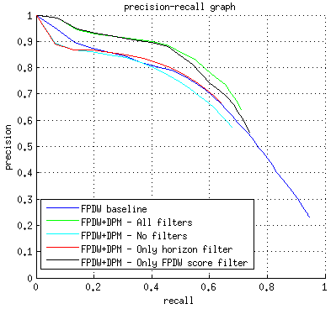Fig. 6: PR for comparison of filtering schemes. Refer text for description.
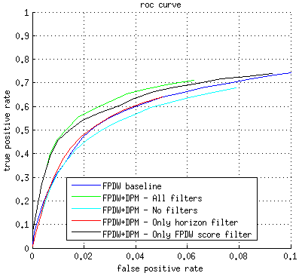Fig. 7: ROC for comparison of filtering schemes. Refer text for description.
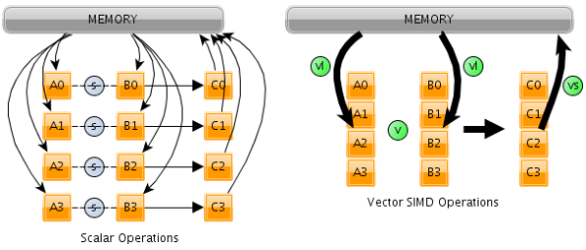Fig. 8: Scalar vs SIMD Vector Addition
The person models in voc-release5 were trained from the PASCAL dataset and have 2 components. Since PASCAL and Caltech datasets differ significantly, a pedestrian model was trained using the Caltech training set. Number of components for this model was set to 1 for reasons discussed earlier.
During testing, the input image was fed first to the FPDW detector to generate object candidates. The FPDW detector was modified as described earlier and trained with images from Caltech training set extracted at every 5th frame.
The object candidates were first filtered based on the image horizon. The image horizon for the Caltech dataset was fixed at 220px. The object candidates that were completely above or below the horizon were filtered out. A large number of false positives from FPDW were symmetric structures like tree tops and wheels. These were effectively filtered out using the horizon filter.
Object candidates with scores above a threshold were always considered true detections, and the corresponding frames were marked as positives. Object candidates from such frames were not processed using the DPM. Increasing this threshold allowed more object candidates to be processed by DPM detector resulting in better detections at the cost of lower fps.
After filtering out unlikely object candidates, the remaining candidates were rescaled to 41px wide. This was done so that all the detections with DPM would be found on the same pair of scales. These rescaled image patches were processed by the DPM in the descending order of their score. On first positive detection, the corresponding frame was marked as positive and the remaining object candidates from that frame were not processed. This effectively reduced the number of times DPM detector had to run, resulting in higher frame rate. A negative consequence of not processing all candidates is that not all the pedestrians in the image are detected. However, the output of the overall system is simply whether to alert the driver or not. And since the driver is to be alerted even if there is a single pedestrian in the view, the output of the system will not change even if all the pedestrians are detected as opposed to just one. In case this cascade is used with a higher level decision making module, which decides whether to alert the driver or take any other complex action, all the object candidates will have to be processed by the DPM module resulting in potentially reduced frame rates.
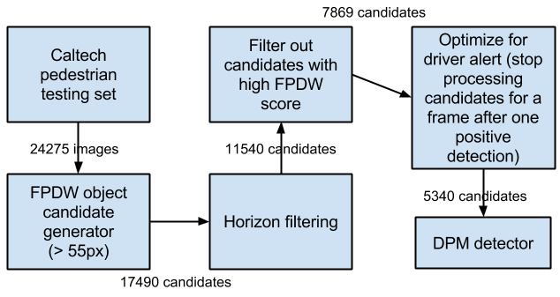Fig. 9: Filtering process for object candidates
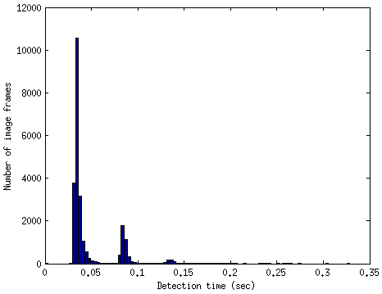Fig. 10: Histogram of detection times per image frame for the cascade.
The effective frame rate gained is analyzed in the Results section.

Results
The detector cascade performs significantly better than just the FPDW detector (Fig. 4 and Fig. 5). The low maximum recall for the FPDW+DPM cascade is due to the use of a cascaded approach. Pedestrians missed by FPDW will never be processed by DPM. This means that they will always be missed by the DPM. Thus recall of the cascade will always be lower than that of FPDW.
The filtering scheme proved very effective for the Caltech testing dataset. When testing on 24275 images, the FPDW generated 17490 object candidates greater than 55px. After horizon filtering, 11540 object candidates remained. After filtering out candidates with high FPDW scores, 7869 candidates remained to be processed. With additional optimization specific to driver alert system, i.e. when limiting the number of positive detection per frame to one, only 5340 were processed by the DPM detector.
The improvements from the filtering scheme can be seen in Fig. 6 and Fig. 7. The 'horizon filter' refers to filtering object candidates based on their location with respect to image horizon. 'FPDW score filter' refers to marking candidates with high enough FPDW score as positive detections. With no filters, all of the 17490 candidates are processed by DPM detector. With only horizon filter, 8335 candidates were processed. For only FPDW score filter, this number is 9589.
The processing times for the detectors are measured on a single 2.4GHz CPU thread without using any SIMD instructions (like Intel's SSE). FPDW takes the lowest time to process with 0.04secs (25Hz) per 640x480 RGB frame. Running the original DPM detector (all scales) on an object candidate of 41px width takes 0.38secs (2.5fps). The optimized DPM (one pair of scales) takes 0.08secs (12.5Hz) to process one image patch. If FPDW detects at least one pedestrian on every frame which is not filtered by horizon filtering, and assuming that the top scoring object candidate is a pedestrian (i.e. one processing instance of FPDW and one instance of DPM), a combined frame rate of 8fps can be achieved. This is almost real time detection.
It is worth noting that not all frames took 0.12secs to process. Based on the results from the filtering scheme, the average processing time for a frame was 0.047secs (21fps). In an end-user application, the processing time can vary depending on the pedestrian traffic, with an ideal upper limit of 0.12secs. When not optimizing for driver alerts, the average detection time on the Caltech testing dataset was 0.0545sec (18 fps)
A histogram of detection times for the Caltech testing dataset is shown in Fig. 10. The impact on detection times of using the filtering scheme can be seen. The histogram also shows that most detections need only the FPDW detector. Moreover, for the image frames passed to the DPM detector, most detections are found when processing the top scoring object candidate.

Detection on ARM
Most mobile devices after 2007 have the ARMv7 cores. These cores support a 128bit single-instruction-mulitple-data (SIMD) instruction set called NEON, for vectorized FPU operations. NEON supports 8-, 16-, 32- and 64-bit integer and single-precision (32-bit) floating-point data and SIMD operations for handling audio and video processing as well as graphics and gaming processing. In NEON, the SIMD supports up to 16 operations at the same time. Intel processor offer a similar SIMD instruction set called SSE2.
SIMD instructions can provide large speed-up simply by being able to perform the same operation on multiple data at the same time (Fig. 8). The potential speed-ups from NEON instruction are estimated using the speeds obtained from using SSE2 on Intel processor and a comparison of speed-ups from NEON and SSE2 [13]. This is because running the cascade on ARM will require reimplementation of the MatLab code of both DPM (voc-release5) and FPDW (Piotr's toolbox) in C. This is outside the scope of this project and remains a future work. The DPM implementation however does provide a SSE2 optimization for convolution operation. Floating point convolution is the most expensive operation for DPM detection. The second most expensive operation is image rescaling, which is common to both FPDW and DPM. A speed up in this operation can greatly increase the overall processing speed.
[13] provides a comprehensive study of performance gains from SIMD instructions applied to multiple image processing operations. The results from [13] for Gaussian blur operation are used, since Gaussian blurring involves convolving the input image with a Gaussian function. The study shows that speed-ups are obtained of up to 1.58x using NEON and up to 3.31x using SSE2.
[14] compares processing times of for building image pyramid using NEON instructions with non-SIMD CPU instructions. The study shows performance gains of up to 10x can be obtained during image rescaling operations.
Comparing non-SIMD execution with SSE2 execution for floating point convolution on the DPM shows speed-up of 3.23x (0.0097secs vs 0.003secs). This result seems consistent with the evaluation presented in [13]. Thus, for floating point convolution operation with NEON instructions, a speed-up of 1.5x is expected.
This is however under the assumption of similar processing times for non-SIMD CPU instructions for Intel and ARM, and similar CPU speeds.

Limitations
One limitation of this approach is inherited from the DPM detector. The original DPM approach is shown to not perform well on images of low resolution [11]. This is due to low resolution images not having sufficient information to generate reliable gradient features. To work around this limitation [11] proposes using multi-resolution models which select the appropriate detector based on the size of the input. A similar approach can work here as well. An alternative to this approach is using 720p videos, which most mobile devices capable of generating. Each frame can be rescaled to 640x480 for FPDW object candidate generation. For each object candidate, the corresponding image patch from the 1280x720 image can be extracted, and passed to the DPM detector. This can improve the ability of DPM to detect pedestrians further away from the vehicle. This was however not possible with Caltech dataset due the limited video resolution.
Another limitation of this approach is the hard coded value for the image horizon. Image horizons can change significantly depending on the slope of the road. To work around this limitation an approach such as [14] can be used to detect the image horizon for each frame. This algorithm uses a combination of canny edge detection and hough line fitting to detect lines in the Z axis. The virtual point of intersection of these lines determines the image horizon. This process is computationally inexpensive and is shown to work at 222fps on a GPU [14]. A similar approach is used by [15] and is shown to run at 85fps on an Intel 2.2Ghz CPU. This algorithm was not implemented in this project due to the Caltech dataset being sufficiently consistent with respect to image horizon.
Both these limitations are easy to overcome and can be easily implemented for a end-user pedestrian detection system.

Future Work
Due to the detector being independent, the DPM detector can replaced by any robust detector which suffers from low speeds due to sliding window and/or multi-scale detection approach. These include CNN based approached which are currently the state-of-the-art for object detection on the ImageNet dataset. A similar cascade is used by [12] where a combination of dense image segmentation based (unsupervised) object candidate generator is combined with a CNN based detector.
An upgrade to DPM is presented in [10] which uses spatio-temporal HOG features (called STHOG) to learn a deformable parts model. STHOG features try to capture the pedestrian's shape as well as movement characteristics. This detector performs much better on the video-based dataset such as the Caltech where consequent frames can be used to generate the spatio-temporal HOG features.
Another improvement for the DPM detector can be made by using better hard negatives. Since DPM uses LSVM to score the input image, it can improve significantly with hard negatives. The original implementation selects hard negative samples from a set of randomly selected negatives. Negative samples from this approach may not be good enough. A better way of generating hard negatives is to use the false positives obtained from FPDW (using cross-validation on the training set) as hard negatives in DPM. This can potentially result in a much better DPM.

Conclusion
This project demonstrates the capability of existing pedestrian detection approaches for an end-user driving assist application. It is evident that such an application need not require a dedicated hardware platform, but can run on everyday hand-held mobile devices like tablets and cell phones. The main barrier seems to be code translation from MatLab to C/C++. This task will include rewriting the entire MatLab implementation of DPM (voc-release5) and FPDW (Piotr's toolbox) in C/C++. For optimization for the ARM platform, a deep knowledge of using NEON instruction set is required. The design and development of such an end-user application remains a future work of this project.
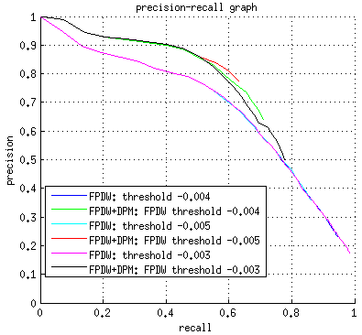Fig. A1: PR plot for different FPDW thresholds.
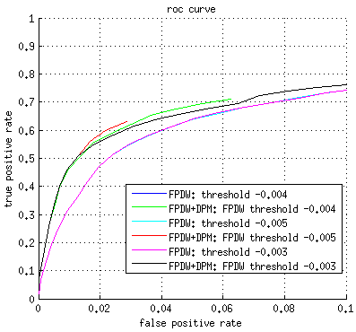Fig. A2: ROC plot for different FPDW thresholds.

References
- Dalal, Navneet, and Bill Triggs. "Histograms of oriented gradients for human detection." Computer Vision and Pattern Recognition, 2005. CVPR 2005. IEEE Computer Society Conference on. Vol. 1. IEEE, 2005.
- Dollár, Piotr, et al. "Integral Channel Features." BMVC. Vol. 2. No. 3. 2009.
- Krähenbühl, Philipp, and Vladlen Koltun. "Geodesic Object Proposals." Computer Vision–ECCV 2014. Springer International Publishing, 2014. 725-739.
- Dimza, Karlis, Te-Feng Su, and Shang-Hong Lai. "Search Space Reduction in Pedestrian Detection for Driver Assistance System Based on Projective Geometry." Advances in Intelligent Systems and Applications-Volume 2. Springer Berlin Heidelberg, 2013. 269-278.
- Dollar, Piotr, et al. "Pedestrian detection: An evaluation of the state of the art." Pattern Analysis and Machine Intelligence, IEEE Transactions on 34.4 (2012): 743-761.
- Dollár, Piotr, Serge Belongie, and Pietro Perona. "The Fastest Pedestrian Detector in the West." BMVC. Vol. 2. No. 3. 2010.
- R. Benenson, M. Mathias, R. Timofte, and L. Van Gool, “Pedestrian detection at 100 frames per second,” in CVPR, 2012.
- P. Felzenszwalb, R. Girshick, D. McAllester, and D. Ramanan, “Object detection with discriminatively trained part based models,” PAMI, vol. 32, no. 9, pp. 1627–1645, 2010.
- Cho, Hyunggi, et al. "Real-time pedestrian detection with deformable part models." Intelligent Vehicles Symposium (IV), 2012 IEEE. IEEE, 2012.
- Chunsheng, H. U. A., Yasushi Makihara, and Y. A. G. I. Yasushi. "Pedestrian Detection by Using a Spatio-Temporal Histogram of Oriented Gradients." IEICE TRANSACTIONS on Information and Systems 96.6 (2013): 1376-1386.
- Yan, Junjie, et al. "Robust multi-resolution pedestrian detection in traffic scenes." Computer Vision and Pattern Recognition (CVPR), 2013 IEEE Conference on. IEEE, 2013.
- Girshick, Ross, et al. "Rich feature hierarchies for accurate object detection and semantic segmentation." arXiv preprint arXiv:1311.2524 (2013).
- Mitra, Gaurav, et al. "Use of SIMD vector operations to accelerate application code performance on low-powered ARM and Intel platforms." Parallel and Distributed Processing Symposium Workshops & PhD Forum (IPDPSW), 2013 IEEE 27th International. IEEE, 2013.
- Sudowe, Patrick, and Bastian Leibe. "Efficient use of geometric constraints for sliding-window object detection in video." Computer Vision Systems. Springer Berlin Heidelberg, 2011. 11-20.
- Benligiray, Burak, Cihan Topal, and Cuneyt Akinlar. "Video-Based Lane Detection Using a Fast Vanishing Point Estimation Method." ISM. 2012.

Appendix A

FPDW threshold – parameter study
FPDW threshold determines the precision-recall trade-off for the object generation phase of the cascade. The only major impact of varying this parameter is on the maximum recall (Fig. A1) / false positive rate (Fig. A2) of the cascade. It however also affects the number of object candidates passed to the DPM detector. The table below shows the number of candidates after various filtering stages.
FPDW threshold | FPDW output  (> 55px) | Horizon filtering | FPDW score filtering | Opt. for driver alerts
-0.003 | 34458 | 20553 | 14987 | 9935
-0.004 | 17490 | 11540 | 7869 | 5340
-0.005 | 8700 | 6653 | 4094 | 2710

